Character Name:  Race:  (if half breed identify races and primary preference clearly)  Player ID:  Character ID: | 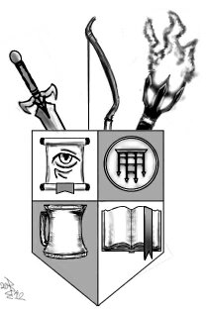
Strength:
Will Power:
Endurance: | (Equals characters hits per location & No. Of health Emblems)
Reflexes:
Intellect:
Weave Score: ( ) (Will Power & Intellect X2)
Common Skills | Uncommon Skills
 | Unique Skills

